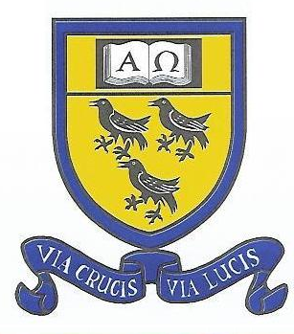
St. Thomas a Becket Catholic Primary School
Tutts Barn Lane, Eastbourne, BN22 8XT
Telephone: 01323 737221
www.stthomasbecketcatholicschool.co.uk email: office@stthomasbecket.e-sussex.sch.uk
Headteacher: Paul Beverton

For admission to Reception in September 2021 the deadline is 15th January 2021.
To apply for your child to attend St Thomas a Becket Catholic Primary School you must,
by 15th January 2021:

- Apply online at;
www.eastsussex.gov.uk/admissions

Complete and return (to the school office) the St Thomas a Becket Catholic Primary School ‘Supplementary Information Form’ (SIF) click link here with all the relevant documentation eg. Certificate of baptism.

Due to the current situation with Covid-19 affecting church attendance, we have issued the following statement:
St Thomas a Becket Catholic Primary School 2021/22 Admissions:

The governing body of St Thomas a Becket Catholic Primary School Eastbourne, has agreed the following statement in order to clarify how its faith-based oversubscription criteria for Catholic applicants will be interpreted whilst churches have been closed or attendance at church is unsafe due to COVID-19.

If a parent/carer attended a given Catholic church prior to the closing of churches for public worship, then where a parent/carer has not subsequently attended worship at a given Catholic church for a given period a parent/carer will be considered to have attended worship at that church for that period where one or more of the following apply:

a) the church was closed for public worship;
b) the Sunday obligation remains suspended;
c) by returning to church the parent/carer would not be taking account of government guidance
effective at the time concerning shielding and protecting persons either moderately or extremely clinically vulnerable to COVID-19. The definition of shielding, if needed, is on the link: -
https://www.gov.uk/government/publications/guidance-on-shielding-and-protecting-extremely-vulnerable-persons-from-covid-19/guidance-on-shielding-and-protecting-extremely-vulnerable-persons-from-covid-19

