How to book for an online Mass

- Search for the Mass you wish to register for, then click on the button next to it labelled “Register”:
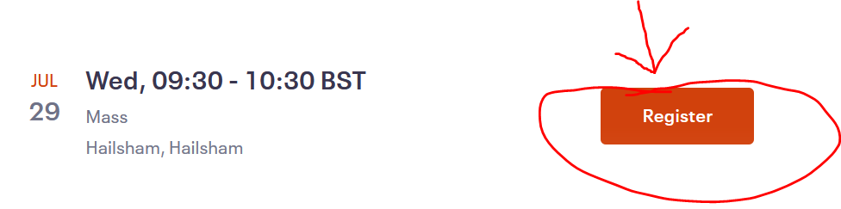
- Select the number of people attending from the dropdown list and select “Register”:
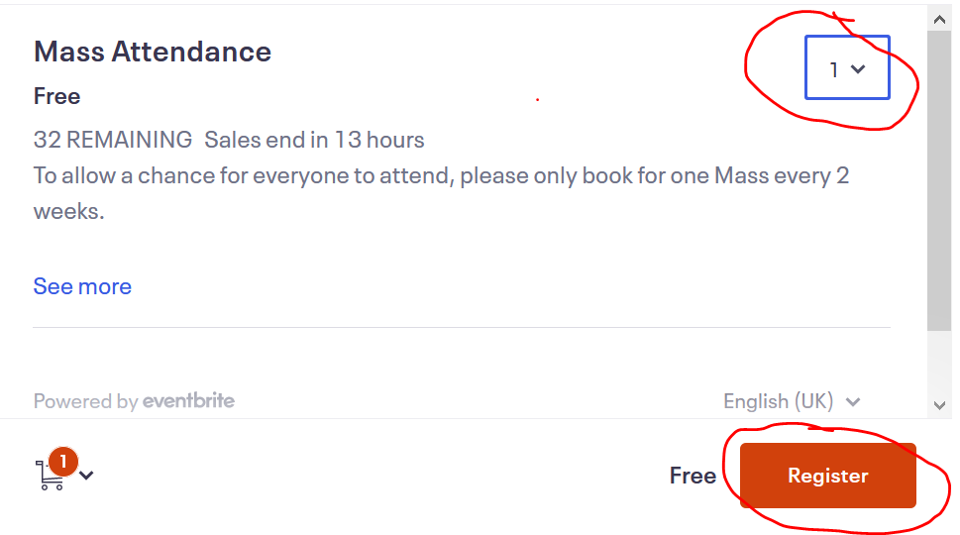
- Scroll down the page and enter your contact details. You will not be able to click the “Register” button until all input boxes with the red Asterix have been completed:
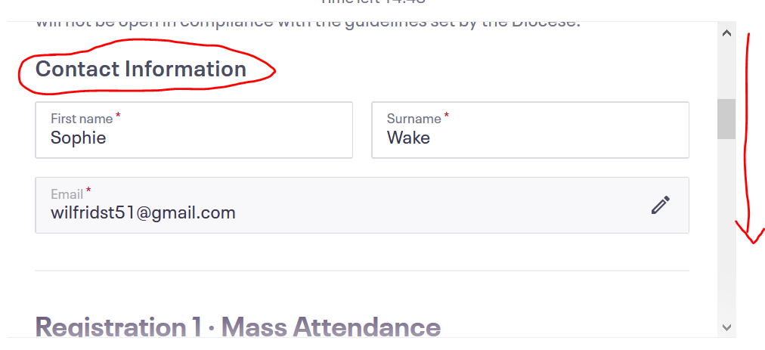
- Congratulations you have booked a Mass!!

