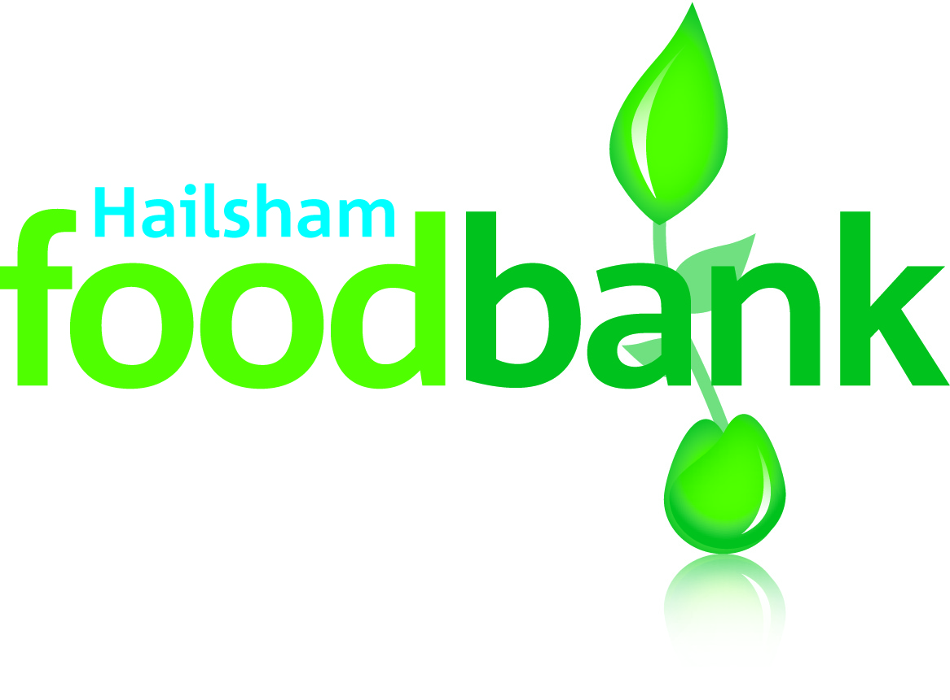
Hailsham foodbank
Sheriff Place
Market Square
Hailsham BN27 1AG
T 01323 398358
E info@hailsham.foodbank.org.uk
W www.hailsham.foodbank.org.uk
Facebook Hailshamfoodbank
Twitter @Hailshmfoodbank
Instagram @hailshamfoodbank

June 2020

It has certainly been a different time at the foodbank, we are very thankful to God for his amazing provision during this time of extreme demand upon our service and for keeping our volunteers and staff safe and well.

We continue to look at new ways in which we can support not only those who need the foodbank, but also to help those who wish to support us, in May we setup the ‘Friends of Hailsham Foodbank’, this has been gaining momentum and if you are interested in donating a regular amount each month, then do contact admin@hailsham.foodbank.org for further information.

We have also looked at ways people can donate our most needed items, without them leaving home and have signed up to, two online platforms that will help maintain food and toiletry levels.

Easho Wishlists (under Julie Coates – as Hailsham Foodbank Manager) a bulk buying platform that guides you on the most needed items.

Bankuet.co.uk (under Hailsham Foodbank) – allows for a financial contribution, which in turn is turned into a most needed item.

If you wish to donate and are unable to go to the local supermarket, these methods of donating might be of interest to you.

At present we are unable to re-open the Foodbank office, and we are therefore most grateful to Christchurch, for their kindness in allowing us to setup a temporary distribution point, thereby allowing for us to abide by the 2 meter guidance which has meant that we are able to have some of our volunteers assist with bag packing, as well as the ease of access for our volunteer home delivery drivers.

Do continue to follow us on Social Media, Julie provides regular updates on our activities and items that we have fallen short of.

Tracey Bond
Volunteer & Community Liaison

